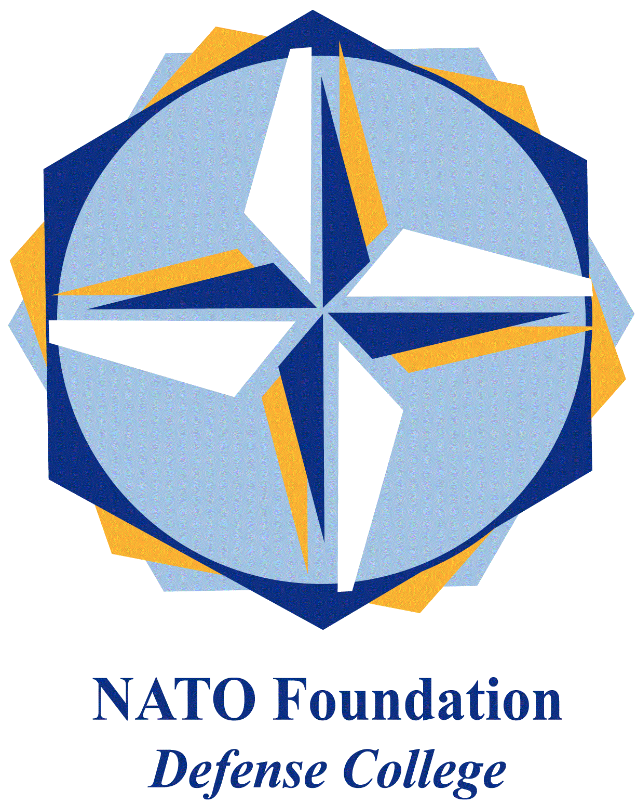
NATO DEFENSE COLLEGE FOUNDATION
STRATEGIC TRENDS
February 2016
GULF
Turkey’s military base in Qatar and the Sunni reactive alignment
Turkey will establish a permanent military base in Qatar (to include army, navy, air force and special forces); at least 3.000 Turkish militaries are going to be deployed. Ankara and Doha are in talks for the signature of a Status of Forces Agreement to frame Turkish military presence in the Al-Thani’s emirate. Turkey would be ready to conduct counter-piracy operations in the Indian Ocean, while the Qatari army would receive high-quality training from Ankara’s peers.
Through a defence hub in Qatar, Turkey will have the potentiality to enhance its military projection not only in the Middle Eastern region, but towards Central Asia too. Qatar, who already hosts United States’ Al-Udeid air base, pursues the differentiation of security alliances, although Washington remains the first, main GCC’s external security provider.
With such a long-term geostrategic choice, Turkey overtly aligns with the Sunni front led by Saudi Arabia, so contributing to furtherly polarize the Middle Eastern field. Ankara has just made available to Saudis the Incirlik base to carry out strikes against the so-called Islamic State in Syria (stopped when Riyadh started to target Shia militias in Yemen). Turkish and Saudis armed forces have been conducting air defence exercises in Konya (central Turkey).
Turkey and Saudi Arabia envisaged the will to deploy special forces (together with Qatar and the UAE) for an hypothetical U.S.-led ground operation in Syria against the “caliphate”: this scenario would escalate regional violence. Moreover, such a military commitment would expose them to overstretching and jihadi attacks at home: Riyadh is jammed in the “Yemeni quagmire” (Restoring Hope operation will reach the apex soon with the battle for Sana’a), while Ankara fights Kurdish militias between Iraq (PKK), Syria (YPG), plus social upheavals in Eastern Anatolia. For these reasons, the announcement of a “Syrian operation” can be firstly read as a diplomatic message for Washington, aimed at demonstrating the Sunni will to really fight “IS”, urging - at the same time - the Americans to stand with them to counterbalance the Russian-Iranian axis.
Turkey, the GCC (and to some extent Israel) have so far underbalanced Iran, emphasizing differences related to domestic regimes on mutual geopolitical interests: but Russia’s military intervention in support of Bashar Al-Assad regime has been a real game-changer, able to put together a reactive Sunni alignment vis-à-vis the Damascus-Teheran-Baghdad front.
To this purpose, Qatar has played a key-role of “bridge” between Turkish and Saudis. In this Middle East deeply polarised along sectarian lines, Doha now recognizes that it can play successful its role only by avoiding direct confrontation with Saudi’s interests, while Riyadh needs Qatar’s mediator skills in order to build regional alliances in times of crisis.
The traditional trade-off between energy and security still persists in the Gulf: due to the diplomatic rift with Russia, Turkey looks for GCC and Qatar’s natural gas supply, as it is attempting to normalise relations with Israel (with an eye to the East-Med pipeline).

